# ITN Session Notes 2022

## Session: CW Control

This was more of a focus group style session.

CW is considering changing the name of CW Control back to ScreenConnect because of it’s strong brand equity with the old name. CW Access Management looks like a strong product, but it only functions from the web portal so far. They’ll need to further integrate with Automate.

Here is their vision map (They didn’t get into the details well because it was more of a focus group…)

Contacts:

END

## Session: Unified Monitoring and Management

CW’s Goal is to have a SINGLE data source (Asio)

**CW RMM Notes from the presentation:**

CW RMM - more integration with Mac

CW RMM - company/sites core services will be added.

CW RMM - reducing the number of clicks to accomplish stuff. Dark mode!

CW RMM - adding more security. Example: notification when a new user tries to schedule scripts on all agents.

CW RMM - improving patching. More reboot functionality. Want to do more with reporting. Going to roll out a new 3pp. No indication of what products. Working on using the windows store. (Speculation: Probably Winget)

CW RMM - working on ticket from scripts (q1?). Working on "run on next check in". Putting time into tickets. Azure monitoring. M365 alerting. Further enhancing intellimon really...sounds like a lot of dev is happening around monitoring.

CW RMM - want to add ability to do azure management directly from cwrmm.

CW RMM - we really need to learn this intune integration. It looks really strong. Adding more to the integration.

CW RMM - network monitoring and management. Being able to monitor, manage, remote in, etc.

CW RMM - adding more backup integration. New co-managed backup program. Similar to our program.

Brightgauge/cwrmm - going to give access to the "snowflake" db so msps will be able to build out what they need. Possibly custom data sets or at least more available datasets.

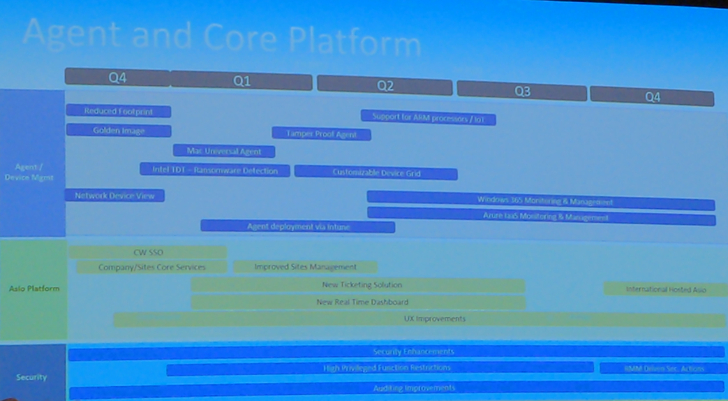

CWA got all of 5 minutes on the stage unfortunately.

Here are the **CWA notes I did take:**

CWA - mentioned that ip restrictions are released? Check on this.

CWA - until the community tells cw to sunset automate it's going to be supported.

CWA - integration with Asio confirmed. Fixing known issues. Move more to the web...as always.

Sounds like there will be new dev for automate, particularly for intune.

## Product Update Keynote

We will need to learn CW access management; it looks very strong from a security position. It needs a lot more to be built out, but it will be the future of getting into the Asio platform.

We will also need to fully understand Asio and how partners will use it. This means we will likely need to learn more about Manage and how technicians work.

Relaunching the whole IT Boost product. There is a nice-looking overlay directly in CWM. This wasn’t gone into with any depth.

CW CPQ is the rebrand of sell. So Sell is now CW CPQ.

Service leadership benchmarking 🡪 Probably worth checking out this url when time permits. Maybe something we can do for our partners.

Sli industry report. ConnectWise.com/slireport

Known issues roadmap. First for manage and other products.

Improvements to the projects in CW PSA.

Dark mode in Asio (the only thing everyone clapped about...)

Self service migration tool for CWA to cw rmm. Mostly focused on migrating client/locations from CWA to RMM. They’ll also be able to do users and a few other things. It doesn’t seem like they are doing much as far as content goes.

SaaS backup for azure ad. Really need to work on integration with our test instance.

Coming soon to cw rmm:

Network monitoring and management. (Beginning 2023)

Cloud monitoring and management.

SaaS backup

Business continuity

Partnering with Acronis, Cream and Keep IT.

BCDR partner program.

Cybersecurity

Siem - hero report.

Exium partnership. Deep endpoint protection with granular server access control.

Identity management.

Partner with evo security.

MFA, SSO, elevated access, Unified directory services.